**Labwork10**

## Task1 Select Parallel execution

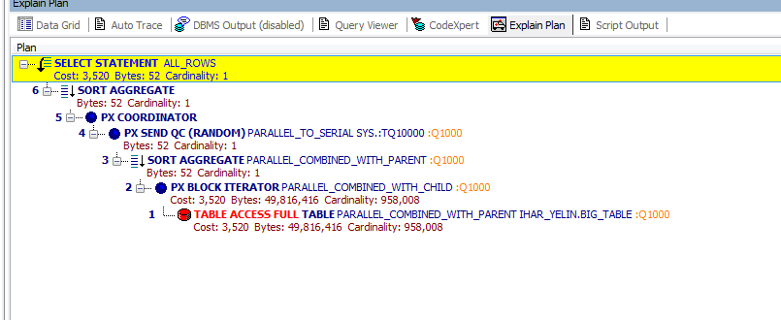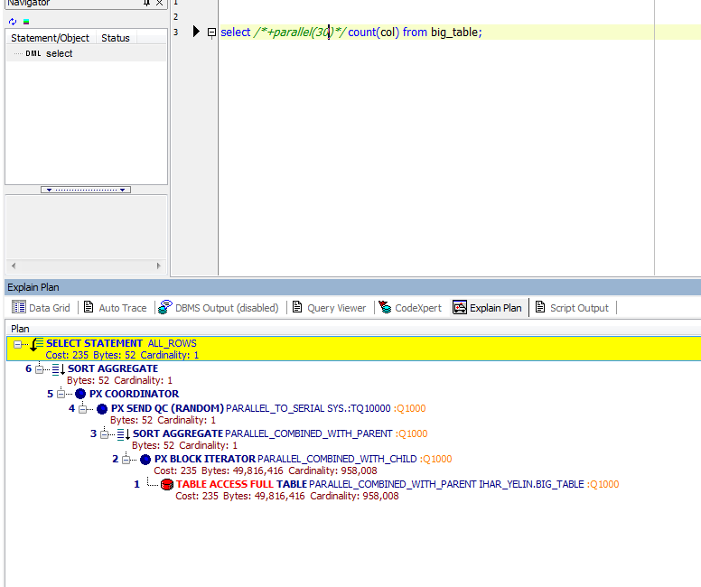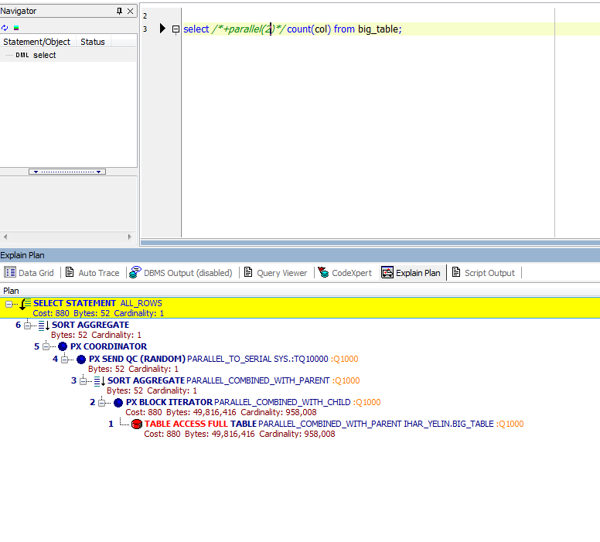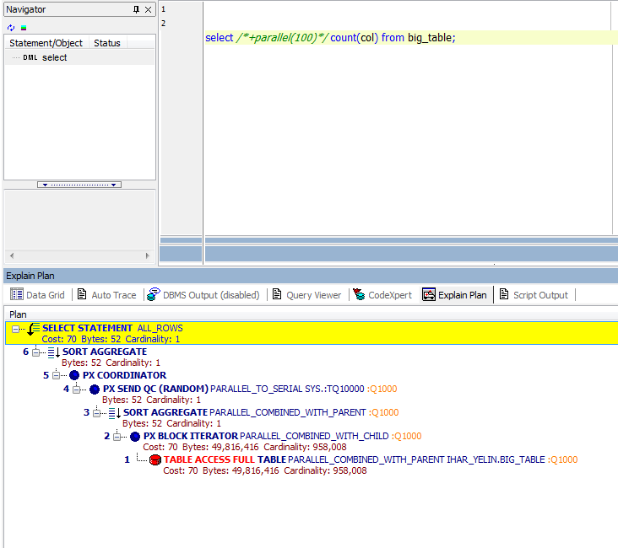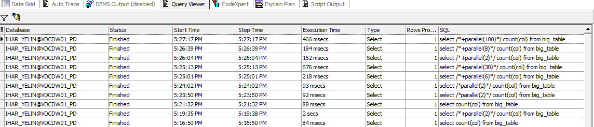

|  |  |  |
| --- | --- | --- |
| Amout of parallel queries | Cost | Time |
| **1** | **3520** | **88** |
| **2** | **880** | **93** |
| **30** | **235** | **676** |
| **100** | **70** | **466** |

## Task2 Parallel DMLC:\Users\Ihar_Yelin\Desktop\Bucha\10\10.PNGC:\Users\Ihar_Yelin\Desktop\Bucha\10\9.PNGC:\Users\Ihar_Yelin\Desktop\Bucha\10\8.PNGC:\Users\Ihar_Yelin\Desktop\Bucha\10\7.PNGC:\Users\Ihar_Yelin\Desktop\Bucha\10\11.PNG

|  |  |  |
| --- | --- | --- |
| Amout of parallel queries | Cost | Time |
| **1** | **6344** | **53** |
| **2** | **3520** | **12** |
| **20** | **352** | **23** |
| **100** | **70** | **12** |

**Task3** Parallel DDL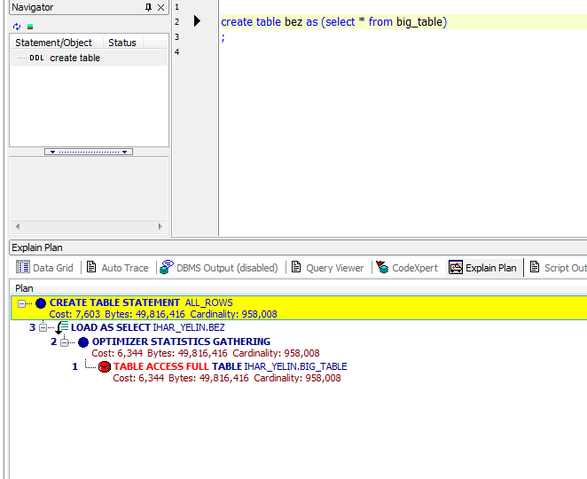**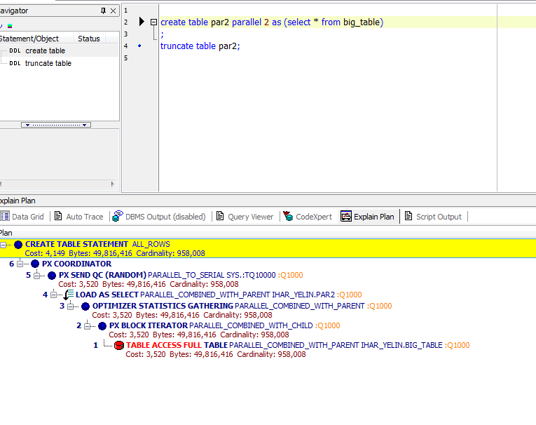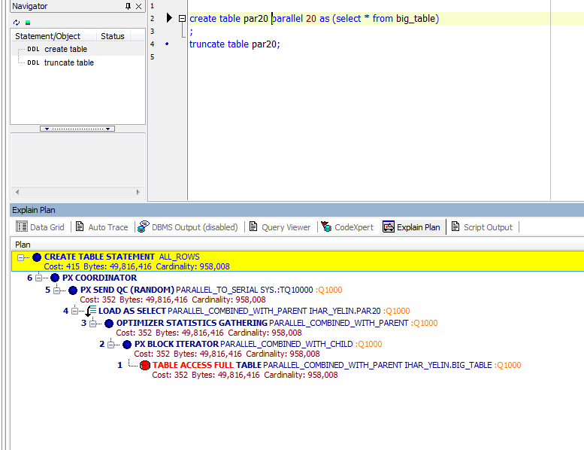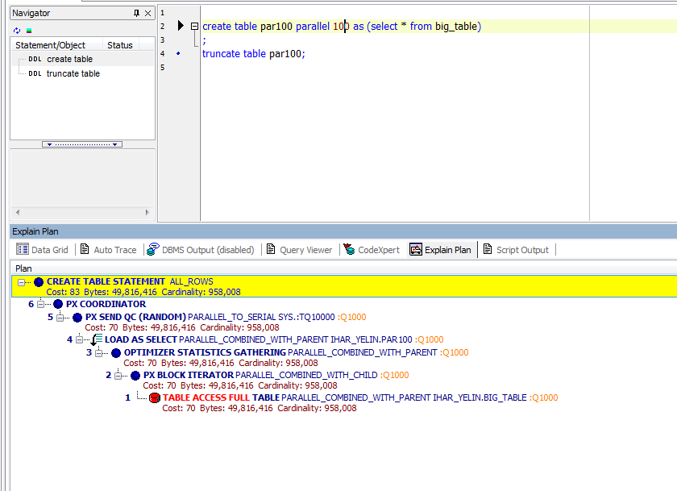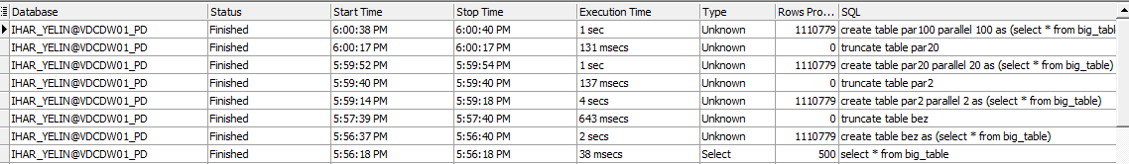**

|  |  |  |
| --- | --- | --- |
| Amout of parallel queries | Cost | Time |
| **1** | **7603** | **2** |
| **2** | **4149** | **4** |
| **20** | **415** | **1** |
| **100** | **83** | **1** |